


PJT03030.R5.SAP.FS.DPP. CRM.ENH.DPP.001 and CRM.ENH.DPP.006 – DPP Enrollment Eligibility Details | 

REVIEWER(S)
Name | Title | Department | Reviewed (date/time)
Manoj Ajgaonkar | SAP Solution Architect | SAP
Jack Hobbick | TESTING SOLUTIONS MGR | Smart Energy Program
Santhosh Shetty | Testing Lead | HCL
Jessica Scott | Audit Controls, Deloitte | Deloitte
Clark Oeler | Audit Controls, Deloitte | Deloitte
Chaitanya Kodela | BTS SDM Solution Architect | BTS
Nancy Pierce | Business Support Consultant | Virtual Contact Center
Abhishek Bansal | SAP Solution Architect | SAP
Ramesh Swarna | HCL Technical Lead | HCL
Alok Bedi | Grid Director | CAP
Brent Kassing | iFactor Lead | iFactor
Jason Iaccio | iFactor Team | iFactor
Craig Bialy | DRMS Lead | Lockheed Martin
Lindsey Schiel | Customer Experience Lead | CE

APPROVER(S)
Name | Title | Department | Approval (date/time)
Clay Engel | Enrollment Vendor Program Manager | Smart Energy Program
Elody Samuelson | DPP Program Manager | Smart Energy Program
Krishna Karunakaram | Smart Energy Project Manager | Smart Energy Program
Jeff Yankley | IT-C&APS-IT App Portfolio-Front Office | BTS
Zach Pakkala | Business Support Consultant | Customer Operations/SE CORE
Blair Estep | CE Release Manager | Smart Energy Program

CONTRIBUTORS
Name | Organization | Area of Contribution
Sudipto Sinha | Cap | Document Creation

VERSION HISTORY
Version | Date | Author(s) | Revision Notes
0.1 | 07/13/2015 | Matt Parker | Initial version
0.2 | 09/15/2015 | Ashish Bhargava | Incorporate review comments

Table of Contents

REVIEWER(S) 2
APPROVER(S) 2
1 OBJECT REQUIREMENT SUMMARY 5
1.1 Object Information and Attributes 5
1.2 Requirements Summary and Business Driver 6
1.3 Assumptions 6
1.4 Current Functionality 6
1.5 Required Functionality 7
1.6 Project / Development Constraints 7
1.7 Performance Criteria 7
1.8 Other Objects Affected 7
1.9 External References 7
1.10 Definitions/Acronyms/Abbreviations 7
2 ENHANCEMENT DESIGN SPECIFICATIONS 9
2.1 Custom Class 12
2.2 Standard Rule 12
2.3 Custom Table Creation 12
2.4 Work Item Delivery Requirements 12
2.5 Triggering Events Determination 12
2.6 Escalation Requirements 13
2.7 Dependencies 13
2.8 Error Handling Method 13
2.9 Post Execution Notification Details 13
2.10 Process Log Details 13
2.11 Other 13
2.12 Unit Test Plan 13
2.13 Information Security 13
2.14 Audit 14
2.15 Questions / Issues / Risks 14

OBJECT REQUIREMENT SUMMARY

Object Information and Attributes
The following is current information about this object and document:
Object ID | CRM_ENH_DPP_001 and CRM_ENH_DPP_006
Title | PJT03030.R5.SAP.FS.CRM_ENH_DPP_001. DPP Enrollment Eligibility Details
Team Which Owns the Object | SAP DPP Enrollment Team
System Version | CRM 7.0
Development Type | Enhancement
Priority | High
Estimated Complexity | High
Link to Process Flow

Requirements Summary and Business Driver
Requirement Id for this requirement
Ref. | PRICEFW ID | Enhancement Description
DPP-038; DPP-039; DPP-042 | CRM_ENH_DPP_001 | This enhancement will do the eligibility checks on the CE CSR initiated Enrollments and push the same to the DPP Enrollment table.
DPP-038; DPP-039; DPP-042 | CRM_ENH_DPP_006 | Creation of new eligibility checks, (consistent with GAP 05) will be implemented in SAP to prevent CSRs from Enrolling in DPP in accordance with the requirements.

1.2.1 Alternatives to Object
The CE CSR will have to manually check the eligibility criteria for the customer for enrollment to DPP enrollment programs (CPP and PTR), during new move in/product change process.

Impact of Implementation
Implementing these changes allows the system to automatically ensure that the accounts being enrolled in the DPP program meet program eligibility criteria.

Impact of No Implementation
If not implemented, users would have take time to determine eligibility manually as the system would not be able to restrict accounts that do not meet the eligibility criteria.

Assumptions
Any changes to existing programs (ex. ASP, People Care, BBPs, etc.) eligibility criteria to check for DPP is out of scope for this release.

Current Functionality
Currently, no logic exists for DPP Enrollment eligibility.

Required Functionality

In order to ensure that customers are eligible for DPP Enrollment, a new ruleset for eligibility rules will be built in BRF+ (similar to the existing DLA Eligibility checks designed in BRF+). This new set of eligibility rules will be called in various scenarios depending on how the enrollment request is initiated. Eligibility will be called both at time of DPP Enrollment request, and again at the time DPP Enrollment actually takes place (as enrollments are staged to take effect at the start of the account’s next billing cycle).

The four scenarios in which eligibility will be called are as follows:
- At the time of Move In, only if a DPP Product for DPP Enrollment associated with the Business Partner sometime in the past has been identified (see PJT03030.R5.SAP.FS.DPP.ENH.DPP.004.Enrollment Processes.v0.1 for details on whether or not to prompt for DPP Enrollment).
- Upon CE user initiating DPP Enrollment request in SAP (exact screen on where this will be is dependent on Enrollment Center creation decision).
- Upon SAP receiving a DPP Enrollment request initiated from the Enroll Vendor
- Upon DPP Enrollment batch job to initiate actual Enrollment in SAP (Rate Category change)

If the system successfully identifies the account as valid and eligible, functionality will be added to the system to automatically create a new entry in the DPP Enrollment Table in ECC (Table name: ZSE_PGMENROLL). Once the account is entered into the table, it will be in Pending status and will remain unchanged in the enrollment table until the associated DPP Enrollment batch job (which will run nightly) determines that DPP enrollment via Rate Change in SAP (along with subsequent device modification as needed) should be initiated. Once enrollment is completed, the status for the account’s entry in the enrollment table will be updated from Pending to Completed.

Project / Development Constraints
None Identified.

Performance Criteria
To be determined in NFR meetings by Business Architecture Team.

Other Objects Affected
None Identified.

External References
None Identified.

Definitions/Acronyms/Abbreviations

EV | Enrollment Vendor
SAP | Systems, Applications & Products in Data Processing
DPP | Dynamic Peak Pricing
CRM | Customer Relationship Management (SAP Front Office)
ECC | ERP Central Component (SAP Back Office)
CE | Consumers Energy
CSR | Customer Service Representative
IC | Interaction Center

ENHANCEMENT DESIGN SPECIFICATIONS
Enhancement Requirements
Number | Description of Requirement
1 | BRF+ Logic for DPP Enrollment Eligibility Checks
2 | Functionality to trigger BRF+ Eligibility Checks in SAP

The DPP enrollment eligibility functionality will need to be called multiple scenarios listed below. Regardless of how these eligibility rules are initiated, SAP will make a call to BRF+ to perform the same set of eligibility rules and return the results to SAP for further processing.

- At the time of Move In, only if a DPP Product for DPP Enrollment associated with the Business Partner sometime in the past has been identified (see PJT03030.R5.SAP.FS.DPP.ENH.DPP.004.Enrollment Processes.v0.1 for details on whether or not to prompt for DPP Enrollment).
- Upon CE user initiating DPP Enrollment request in SAP (exact screen on where this will be is dependent on Enrollment Center creation decision).
- Upon SAP receiving a DPP Enrollment request initiated from the Enroll Vendor
- Upon DPP Enrollment batch job to initiate actual Enrollment in SAP (Rate Category change)

2.0.1 Move In Prompt Eligibility:
Once the Move In process is completed in SAP, a new validation will be added to identify whether or not the customer has previously been on a DPP rate by interrogating the premise for an associated installation to check for a DPP Rate Categories existence (RS_1007 or RS_1008). If this logic determines the account was previously on a DPP rate, a newly created RFC enabled wrapper will be created that can be called from both CRM and ECC. The wrapper FM will have the logic to call the BRF+ DPP Enrollment Eligibility rules (similar to how DLA is performed – see screenshot below) in order identify whether or not the system should display a prompt to the user to suggest DPP Enrollment.
Please Note – this may be a more broad set of eligibility rules if an enrollment center is used for DPP enrollments.

If the account does not pass all of the BRF+ eligibility rules for DPP Enrollment, the error will be returned to SAP. If the account does not pass all eligibility checks, no further DPP Enrollment actions should occur in the SAP system and the system prompt for DPP enrollment should not be displayed.

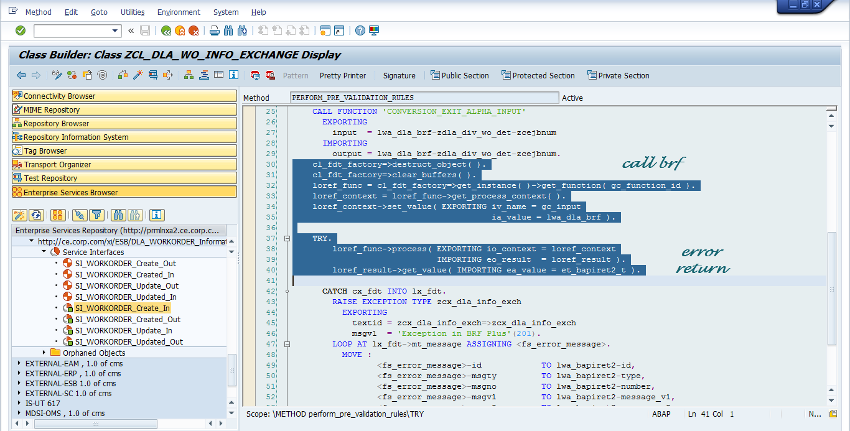

If the account passes all of the BRF+ eligibility rules for DPP Enrollment, SAP should be updated that it was completed successfully and that the account is eligible for DPP Enrollment. Upon receiving the response from BRF+, a system prompt will be displayed to the user suggesting DPP Enrollment. For any other specific details in regards to the functionality around the Move In Prompting for DPP Enrollment, please refer to the PJT03030.R5.SAP.FS.DPP.ENH.DPP.004.Enrollment Processes.v0.1 Functional Specification).

2.0.2 CE DPP Enrollment Initiation Eligibility Logic:
Once a Consumers Energy user initiates DPP Enrollment in the CRM system, SAP should call the same newly created RFC enabled wrapper listed mentioned in section 2.0.1 to call the BRF+ DPP Enrollment Eligibility rules to identify whether or not to allow the DPP Enrollment to be initiated successfully in SAP.

If the account does not pass all of the BRF+ eligibility rules for DPP Enrollment, the error will be returned to SAP. If the account does not pass all eligibility checks, no further DPP Enrollment actions should occur in the SAP system. The ineligible reason should be returned to SAP and displayed to the user.

If the account is determined as eligible by passing all eligibility rules, the system will trigger a newly created function module (FM: ZSE_DPPEnroll_Initiate) in ECC to create a new Pending Enrollment entry in the DPP Enrollment staging table in order to successfully initiated the DPP Enrollment process (for specific details about table updates, refer to PJT03030.R5.SAP.FS.DPP.Receive Enrollment Request from 3P.CS_INT_DPP_003 Functional Specification).

2.0.3 EV DPP Enrollment Eligibility Logic (ECC System changes):
Once a DPP Enrollment request is initiated from the Enrollment Vendor, SAP will receive an inbound interface with the enrollment details in ECC (refer to PJT03030.R5.SAP.FS.DPP.Receive Enrollment Request from 3P.CS_INT_DPP_003 Functional Specification). Once the response comes into SAP, it will trigger an event to call the same newly created RFC enabled wrapper listed mentioned in the sections above to call the BRF+ DPP Enrollment Eligibility rules to identify whether or not to allow the SAP system to continue with the DPP Enrollment initiation.

If the account does not pass all of the BRF+ eligibility rules for DPP Enrollment, BRF+ should return the failed eligibility rule to SAP. Upon receiving the response, SAP needs to trigger the
outbound interface for the rejected enrollment request back to the Enrollment Vendor including the ineligibility flag and ineligibility reason (for details on Outbound Interface refer to PJT03030 R5 SAP FS DPP Enrollment Pending confirmation to EV CS INT DPP 004 Functional Specification). No further DPP Enrollment actions should occur in the SAP system.

If the account is determined as eligible by passing all eligibility rules, the system will trigger a function module in ECC to create a new Pending Enrollment entry in the DPP Enrollment staging table (for specific details about table updates, refer to PJT03030.R5.SAP.FS.DPP.Receive Enrollment Request from 3P.CS_INT_DPP_003 Functional Specification).

2.0.4 DPP Enrollment Batch Job initiates DPP Enrollment:
Once the DPP Enrollment batch job identifies enrollment can occur for an account that is pending enrollment in the DPP Enrollment table, it will need to run the account through eligibility again to ensure that the account is still eligible for DPP Enrollment (as accounts are staged in the Enrollment table in Pending status until the beginning of the next billing cycle).

BRF+ DPP Enrollment Eligibility Logic:
Regardless of the way the BRF+ DPP Enrollment eligibility rules are called, BRF+ will always execute the same set of business rules to identify whether or not the account is eligible, and should process as follows:

Example Screenshot of existing DLA BRF+ Function (for reference only):
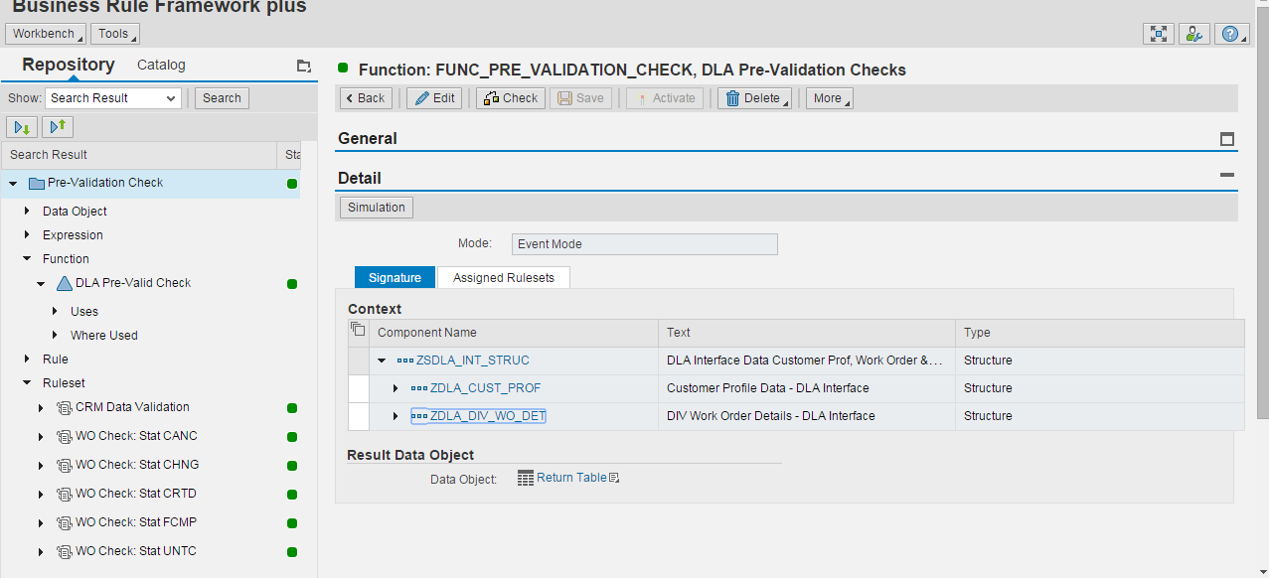

BRF+ DPP Enrollment Rules:
- Is Contract Account Class equal to ‘RES’? (Table: FKKVKP – Field: KTOKL)
  - Yes › Go to step 2.
  - No › Return Failure for ‘Not Residential’ to SAP

- Does an actively installed meter exist with Capability and Capability group for Over The Air Reading Capability?
NON GCM Eligible Values:
EGERH-KOMBINAT = 'Z'
EGERH-AMS not space
EGERH-AMCG_CAP_GRP not space
TEAMI_AMCGCAP-AMCG_CAP = 3
GCM Eligible Values:
EGERH-KOMBINAT = 'M'
ETYP-SMART_METER = 2
  - Yes › Go to step 3.
  - No › Return Failure for ‘No Active Over the Air Devices’ to SAP

- Is the Contracts Payment Plan Type and Start Month not populated? (Table: EVER Field: PYPLT = ‘BP’ OR ‘WPP’ or ‘SPP’ AND PYPLS ≠ Blank).
  - Yes › Return Eligibility Passed back to SAP
  - No › Return Failure for ‘Active Payment Plan or Pre-Pay Account’

If BRF+ returns a Failure response and reason to SAP, SAP should then prevent the DPP enrollment from occurring in the system, and display the following system message to the user.

Ineligible System Message example:
“Ineligible for DPP Enrollment due to: <Failed Eligibility Rule>”

If the account is identified as eligible, the batch job will initiate the rate change to the DPP Program specific rate category in ECC, syncing it up with the product selected in CRM for either the CPP or PTR Program. Once the rate in changed in ECC, it will automatically trigger additional device configurations to be performed in the system as needed (for more details on batch job and corresponding jobs please refer to PJT03030.R5.SAP.FS.DPP.REP.001.Enrollment Completion Batch Job).

Custom Class
None Identified.

Standard Rule
None Identified.

Custom Table Creation
None Identified.

Work Item Delivery Requirements
None Identified.

Triggering Events Determination
None identified.

Escalation Requirements
None Identified.

Dependencies
None Identified.

Error Handling Method
Error handling will depend on which system is making the call to the RFC Enabled wrapper and receiving the BRF+ eligibility results. In the cases where it is triggered and returned to CRM, if an error occurs during the eligibility rules processing in SAP while either calling the DPP Enrollment BRF+ Function or receiving a response from BRF+, class CL_BSP_WD_MESSAGE_SERVICE can be used to register error messages. Process should be aborted followed by the error message.

If the enrollment request comes from the Enrollment Vendor, any errors that occur during processing will trigger an error to be sent back to the EV and prevent further processing (for more details on error handling for this scenario, please refer PJT03030.R5.SAP.FS.DPP.Receive Enrollment Request from 3P.CS_INT_DPP_003 Functional Specification).

If an error occurs once the batch job is initiated to complete the DPP Enrollment, an error should be written to the record in the Enrollment Table for the account (for more details on error handling in this scenario, please refer to PJT03030.R5.SAP.FS.DPP.REP.DPP.001.DPP Enrollment Completion Batch and Rate Change.v0.1 functional specification).

Post Execution Notification Details
None Identified.

Process Log Details
None Identified.

Other
None Identified.

Unit Test Plan

Information Security
None Identified.

Information Classification
None Identified.

Security Roles (Profiles and Authorizations)
None Identified.

Table Security (if applicable)
None Identified.

ABAP Program Security (if applicable)
None Identified.

Audit
None Identified.

Questions / Issues / Risks
Open Item – Should Poor communicating meters be excluded from DPP as an eligibility rule? Zach/Clay to follow up to determine.

